
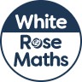
Maths Overview- Year 6



