
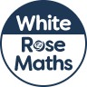
Maths Overview- Year 5



