
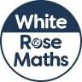
Maths Overview- Year 4


