

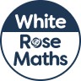
Maths Overview- Year 3



