
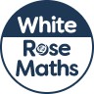
Maths Overview- Year 2



