
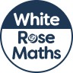
Maths Overview- Year 1



